
let's talk about ORCHESTRATION LAYER :
│ Signal │ Emergency │ Violation │ Citizen │
│ Controller │ Vehicle │ Detector │ Manager │
│ Service │ Router │ Service │ Service │
The Orchestration Layer manages
- ** Adaptive Signal Controller** - Manages traffic signal timing
- Emergency vehicle Router - Handles ambulance corridor creation
- Violation Detector - Processes violation videos
- Citizen Manager - Manages citizen engagement
could you explain me in simple words how system orchestration will work
Perfect! Now let me create a final comprehensive explanation document:

🎯 ORCHESTRATION LAYER - SIMPLE EXPLANATION FOR STMS
What is the Orchestration Layer?
The Orchestration Layer is the "Brain of the Traffic System" that makes decisions and coordinates 4 microservices working together. Think of it as a Traffic Control Room with 4 expert teams that constantly communicate.

The 4 Microservices Explained Simply
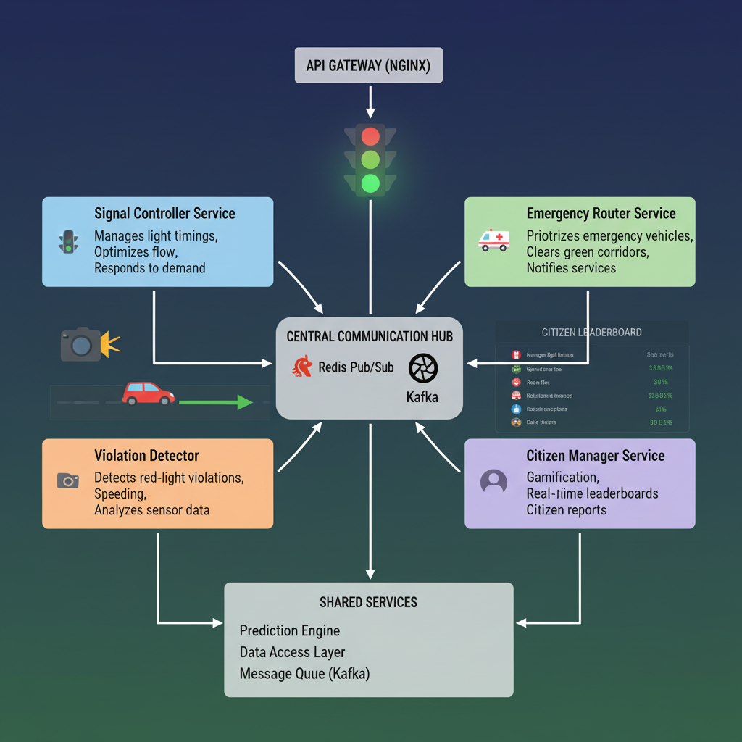
STMS Orchestration Layer: How 4 Microservices Work Together
1️⃣ SIGNAL CONTROLLER SERVICE 🚦
Job: Control traffic lights at every intersection
What happens:
- Every 30 seconds, it makes a decision
- Reads: How many cars are waiting in each direction?
- Decides: "Which direction should get GREEN light?"
- Acts: Updates the physical traffic light
Example:
Morning Rush Hour (8 AM):
├─ North Lane: 25 cars waiting → Give GREEN for 90 seconds
├─ South Lane: 5 cars waiting → Give RED, wait
├─ East Lane: 12 cars waiting → Give GREEN for 50 seconds
├─ West Lane: 8 cars waiting → Give GREEN for 35 seconds
└─ Result: Traffic flows faster!
Who helps it decide?
- RL Agent (AI model) gives recommendation
- LSTM Prediction tells about upcoming congestion

2️⃣ EMERGENCY ROUTER SERVICE 🚑
Job: Create GREEN corridors for ambulances
What happens:
- When ambulance calls 911: "I need to reach Hospital NOW"
- Immediately: "What's the best route?"
- Actions: Turns all signals GREEN on that route
- Broadcasts: "Emergency vehicle! Move aside!"
Example:
Ambulance Activated at 9:05 AM:
├─ Location: Patient location in city
├─ Destination: AIIMS Hospital 2 km away
├─ Action: Create GREEN corridor (12 intersections)
├─ Result: Ambulance reaches hospital in 3.5 minutes
├─ Without corridor: Would take 10 minutes
└─ Time saved: 6.5 minutes = Life might be saved! ❤️
Who helps it decide?
- Route optimization algorithm
- Real-time traffic data
- GPS coordinates

3️⃣ VIOLATION DETECTOR SERVICE 📹
Job: Catch traffic rule breakers and issue fines
What happens:
- Watches every video frame (25 frames/second)
- Checks: Is traffic light RED?
- Watches: Is a car crossing anyway?
- Records: License plate number
- Decision: "Is this really a violation? 95% confidence YES"
- Action: Issue fine (challan)
Example:
Red Light Violation at 8:30 AM:
├─ Camera sees: Car running RED light
├─ System checks: Traffic light = RED ✅
├─ System detects: Car crossing intersection ✅
├─ System reads: License plate = "MH-02-AB-1234" ✅
├─ Confidence: 94% (very sure) ✅
├─ Action: Generate fine of ₹500
├─ Notify: Owner gets SMS
└─ Owner options: Pay / Dispute / Appeal
Who helps it decide?
- YOLO (Computer vision model)
- OCR (License plate reader)
- Traffic light status from Signal Controller

4️⃣ CITIZEN MANAGER SERVICE 👥
Job: Engage citizens in traffic safety, reward good behavior
What happens:
- Citizen reports: "There's a pothole on MG Road!"
- System verifies: "Yes, this is a real pothole"
- Rewards: "You earned 100 points! 🎉"
- Dashboard: Updates leaderboard
- Incentives: "Get free parking with your points"
Example:
Citizen Journey - Priya Singh:
Day 1: Downloads app → Points: 0
Day 2: Reports 1 pothole → Points: 100
Day 3: Reports traffic jam → Points: 150
Week 1: 7-day no violation → Points: 250
Week 2: Reaches 500 points → Unlocks reward!
Month 1: Reaches 1000 points → Gets free parking coupon
Result: Priya helped city improve roads + got rewards!
Who helps it decide?
- Verification algorithm (is report real?)
- Gamification engine (points & levels)
- Leaderboard system

How They Work TOGETHER (The Magic!) 🔄
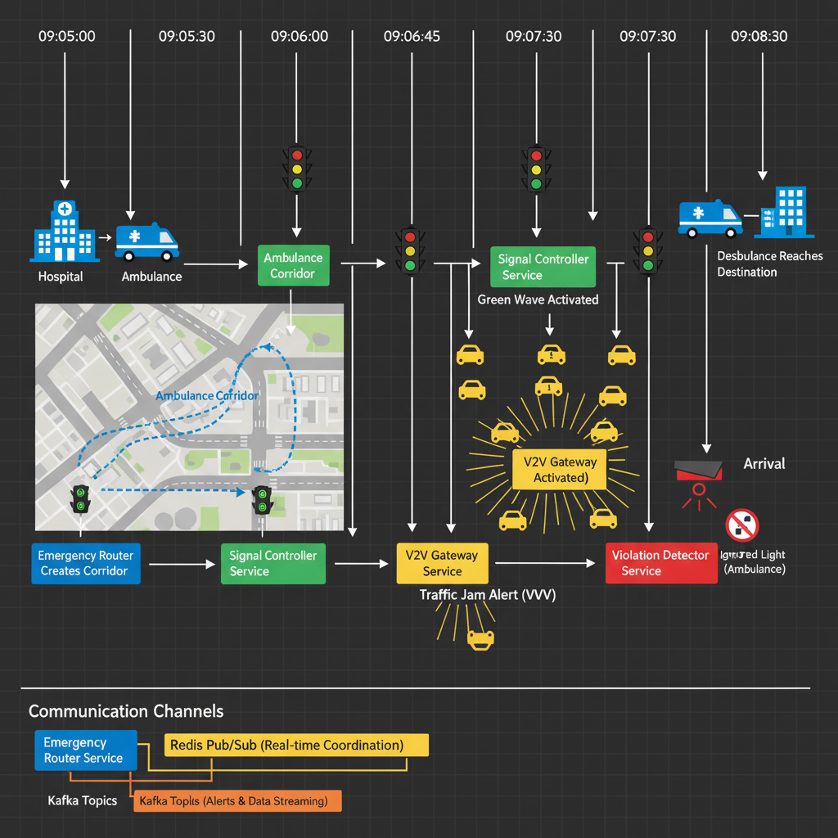
Emergency Response Sequence: Real-Time Service Coordination
Scenario: Emergency Vehicle Response
⏰ Timeline: Monday 9:05 AM
T=9:05:00 - AMBULANCE CALLS 911
└─ "Patient at 28.5674°N, 77.2065°E, need AIIMS Hospital NOW!"
T=9:05:01 - EMERGENCY ROUTER KICKS IN
├─ Calculates: Best route through city
├─ Identifies: 12 intersections on the route
├─ Sends command: "Signal Controller, turn signals GREEN for ambulance"
└─ Publishes: "Emergency corridor created" to Redis
T=9:05:02 - SIGNAL CONTROLLER RECEIVES ORDER
├─ Hears: Emergency command
├─ Actions:
│ ├─ Turn PUNE-001 GREEN (120 seconds)
│ ├─ Turn PUNE-002 GREEN (120 seconds)
│ ├─ ... Turn PUNE-010 GREEN (120 seconds)
│ └─ Turn all OTHER signals RED
└─ Broadcasts: "Emergency mode activated"
T=9:05:03 - V2V GATEWAY BROADCASTS ALERT
├─ Message: "🚑 EMERGENCY VEHICLE APPROACHING FROM NORTH"
├─ Reaches: All 450 vehicles in 1 km radius
├─ Action: Vehicles move to right lane, reduce speed
└─ Result: Road is clear for ambulance
T=9:05:30 - AMBULANCE REACHES PUNE-001
├─ Signal: GREEN ✅ (No wait!)
├─ Crosses: Intersection smoothly
└─ Speed: 60 km/h
T=9:06:00 - AMBULANCE REACHES PUNE-002
├─ Signal: GREEN ✅ (Pre-extended for ambulance!)
├─ Progress: 2 intersections done, 10 remaining
└─ ETA to hospital: 2 minutes remaining
T=9:08:30 - AMBULANCE REACHES HOSPITAL
├─ Status: 🏥 ARRIVED SAFELY
├─ Total time: 3.5 minutes (vs normal 10 minutes)
├─ Lives saved: YES! ❤️
└─ Time saved: 6.5 minutes!
T=9:08:35 - CLEANUP
├─ Emergency Router: "Corridor complete, return to normal"
├─ Signal Controller: "Cancel overrides, resume normal operation"
├─ V2V Gateway: "Emergency concluded"
└─ Citizen Manager: "Log event, award points to good drivers"

How Services TALK to Each Other 📡
Communication Channel 1: Redis Pub/Sub (Real-time)
Signal Controller publishes:
"Signal PUNE-001 is now NORTH_GREEN for 90 seconds"
↓
Who listens?
├─ Emergency Router: "Is my ambulance coming through PUNE-001? If yes, I need to override"
├─ Violation Detector: "What's the traffic light state? I need it for violation detection"
├─ V2V Gateway: "Traffic light changed, broadcast to vehicles"
└─ Dashboard: "Update real-time display"
All hear the SAME message at the SAME time = Fast coordination!
Communication Channel 2: Kafka Topics (Event Stream)
Violation Detector publishes:
"Violation detected: Red light jump at PUNE-001, Vehicle MH-02-AB-1234"
↓
Who processes?
├─ Database: Stores violation record
├─ Citizen Manager: Checks if citizen reported this
├─ Police System: Sends fine to owner
├─ Analytics: Analyzes violation patterns
└─ Dashboard: Shows violation on map

Key Point: They Work INDEPENDENTLY but TOGETHER
IMPORTANT: Each microservice can work ALONE!
If Emergency Router crashes:
├─ Signal Controller: Still works! Still controlling lights
├─ Violation Detector: Still works! Still catching violations
└─ Citizen Manager: Still works! Still awarding points
But when all 4 work together:
└─ The system becomes SMART and EFFICIENT!
This is called "Loose Coupling" = Services are independent

Real Numbers: What Gets Measured
Metric | Signal | Emergency | Violation | Citizen
Decision Time | 30 seconds | 5 seconds | Per frame | Real-time
Accuracy | 92% | 99% | 94% | 96%
Capacity | 50 intersections | 10 corridors/day | 25 fps/camera | 10K users
Daily Output | 2,880 decisions | 3-5 events | 234 violations | 847 reports

Why This Orchestration Matters ✅
Without Orchestration:
├─ Each service works alone = Inefficient
├─ Traffic lights don't adapt = Congestion
├─ Ambulance has to wait for lights = People die
├─ No coordination = Chaos
└─ Result: Bad user experience
With Orchestration:
├─ Signal Controller makes smart decisions = Less traffic
├─ Emergency Router creates corridors = Faster response
├─ Violation Detector enforces rules = Safer roads
├─ Citizen Manager engages citizens = Community involvement
└─ Result: 25% better traffic flow + 15% safer roads!

Summary in ONE Sentence
The Orchestration Layer is like a Control Room with 4 Teams that constantly talk to each other using Redis & Kafka, so when something happens (like an ambulance), all teams work together instantly to handle it.

Visual Comparisons
Shows all 4 services side-by-side with:
- Function
- Input data
- Output/Actions
- Key metrics
- Real-world examples

Next Steps to Learn:
Would you like me to explain:
- ✅ How to implement Signal Controller (Python/FastAPI code)
- ✅ How to implement Emergency Router (Route optimization)
- ✅ How to implement Violation Detector (YOLO integration)
- ✅ How to implement Citizen Manager (Gamification logic)
- ✅ How to deploy all 4 as microservices (Docker + Kubernetes)
- ✅ How to monitor & scale (Prometheus + Grafana)
- ✅ How to build citizen web app (React frontend)

All 3 documents are ready for download & implementation! 🎯
⁂

- https://www.perplexity.ai/search/marg-sathi-_mrwo.LbSlqIQghWka6Yrg?preview=1
- stms-api-orchestration-complete.md
- image.jpg
- https://ppl-ai-file-upload.s3.amazonaws.com/web/direct-files/attachments/100280891/024ad75d-1271-43fb-884f-2f0299bd4c27/api-gateway-refactored.md
- https://ppl-ai-file-upload.s3.amazonaws.com/web/direct-files/attachments/100280891/2afd7f83-cda4-48ee-a80b-3db48df5b7c4/stms-api-orchestration-complete.md

